**Procedure-**

Step 1: Install Xen Server

Step i-: Insert Bootable XenServer CD into CD ROM and Make first boot device as a CD ROM from BIOS

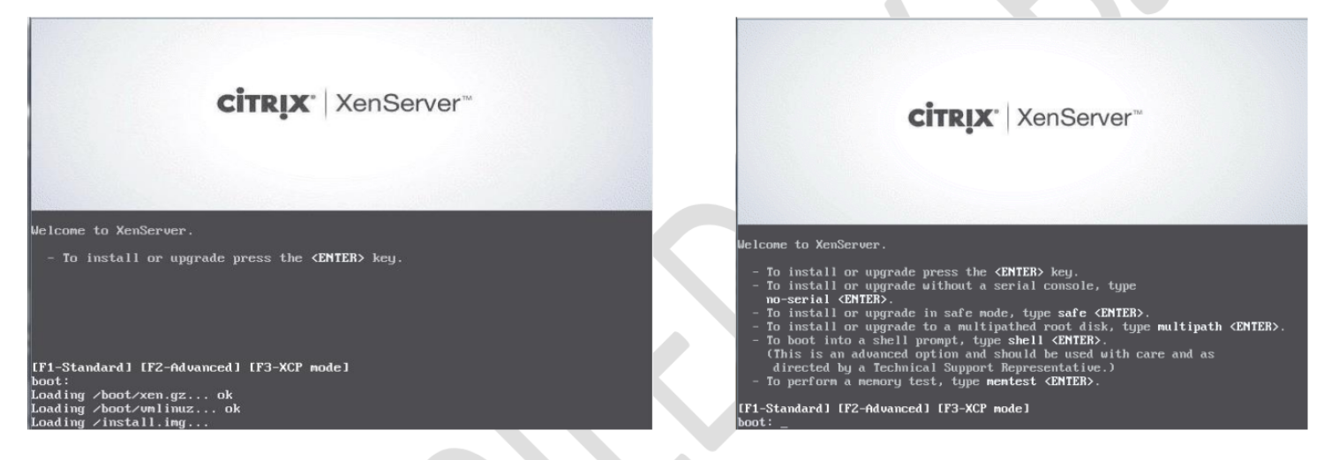

Step ii-: press F2 to see the advanced options, otherwise press Enter to start installation



Step iii -: Select Keyboard Layout

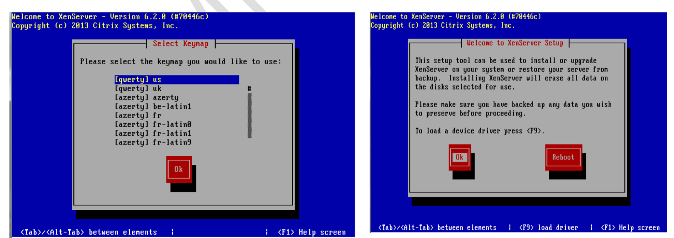

Step iv -:Press Enter to load Device Drivers



Step v -:Press Enter to Accept End user license Agreement

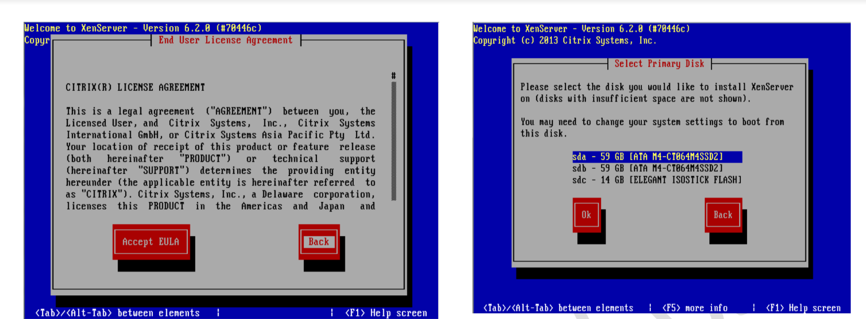

Step vi -:Select Appropriate disk on which you want to install Xen server



Step vii -:Select Appropriate installation Media

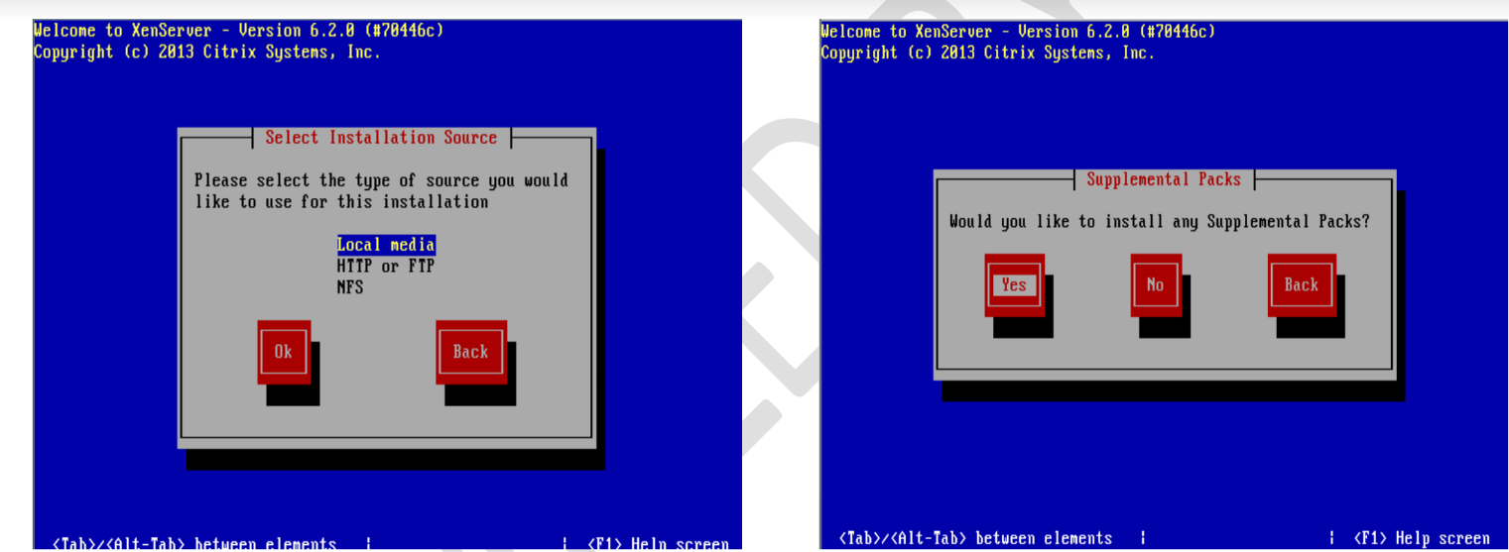

Step viii -:Select Additional Packages for installation



Step ix-: Specify Root password

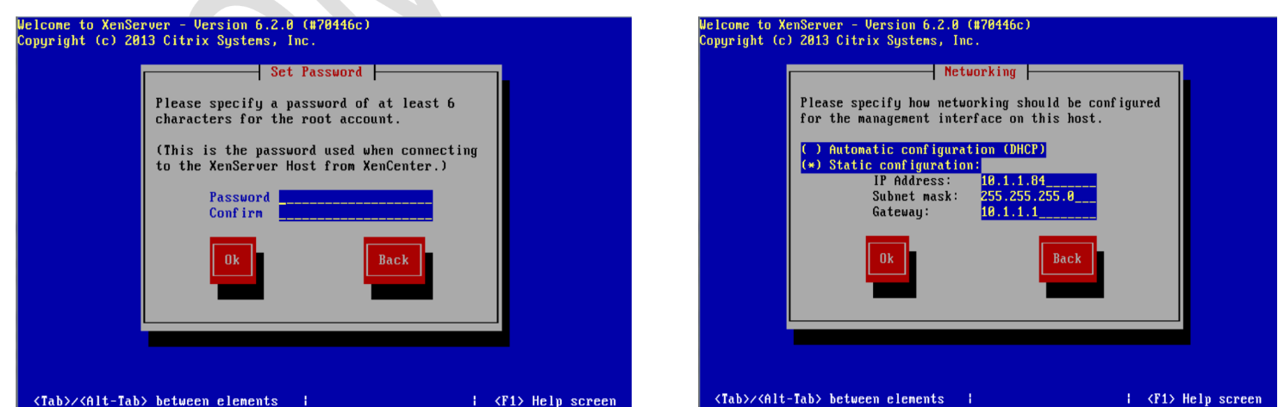

Step x -: Specify IP Address to a Xen Server



Step xi-:Select Time Zone

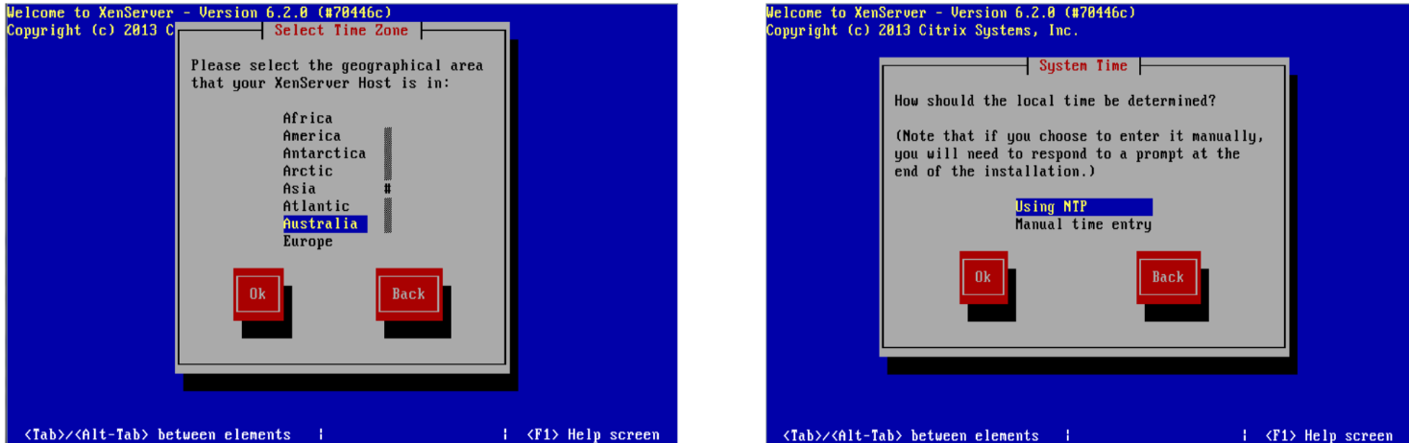

Step xii-:Specify NTP Servers address or use manual time entry then start installation



Once installation is done you will see the final screen shown below.

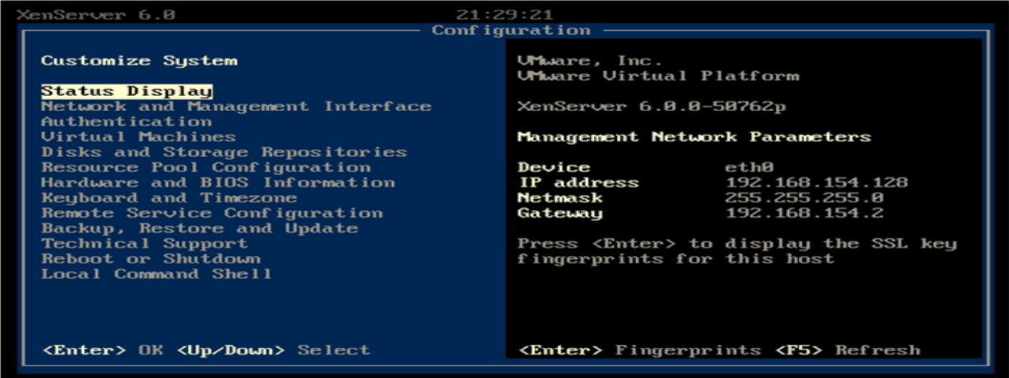

**Step 2:Connect Xenserver to XenCenter**

Firstly, download the xen center, a management utility from the xen server by opening the xen server's IP address as a URL on the browser. Once Xen center is downloaded, install it.Open Xen center from the start menu of Windows.

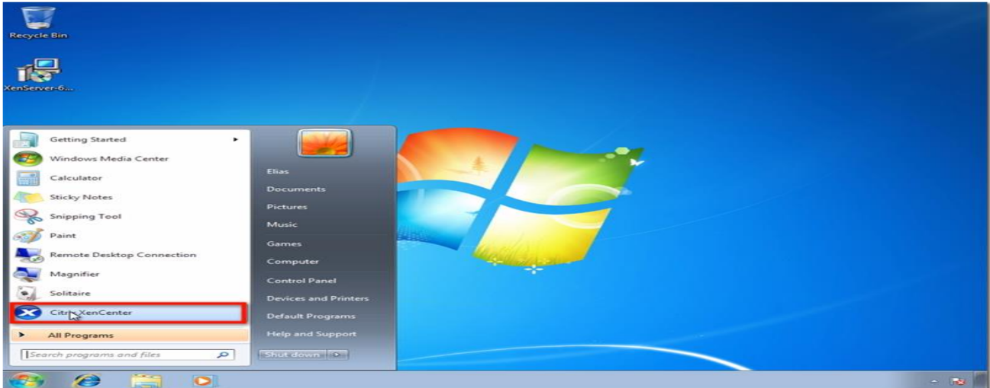

Here’s how XenCenter looks like (see screenshot below) before any hosts, resource pools, and so on, are added to it. To connect to the XenServer host you configured earlier, click Add a server.

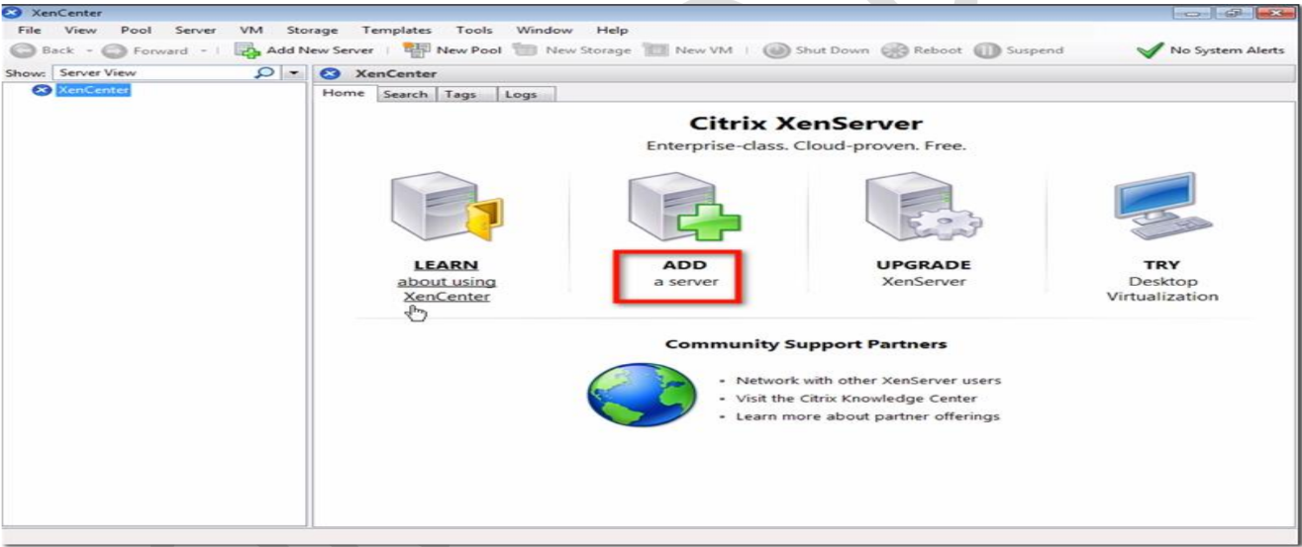

Enter the IP address I asked you to take note of earlier. Also enter the password you assigned for your root account. Click Add.

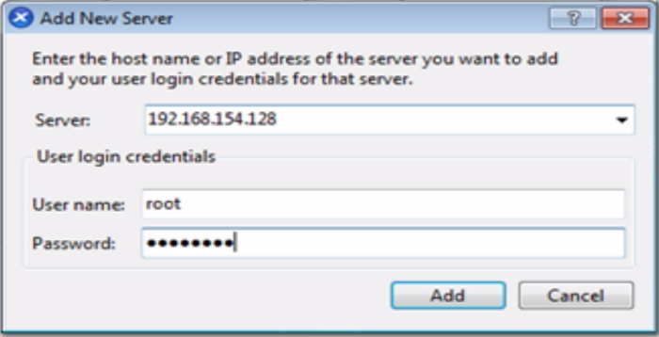

One of the first things you want to make sure of as you're adding a new XenServer to XenCenter is to save and restore the server connection state on startup. Check the box that will do just that.

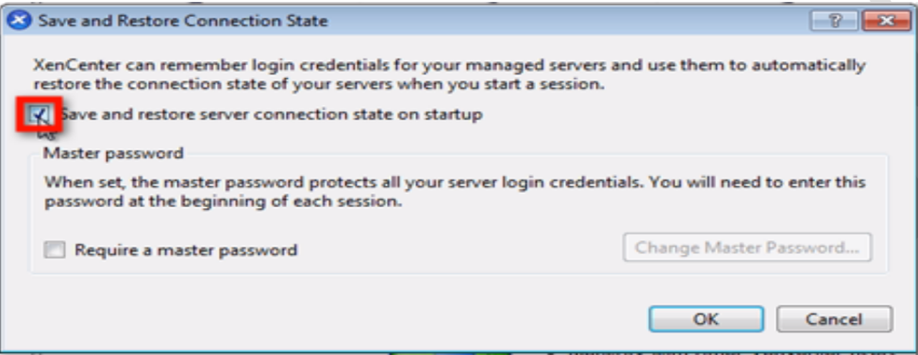

Once you do that, you will be allowed to configure a master password for all the XenServers you’ll be associating with this XenCenter. Click the Require a master password checkbox if that’s what you want to do, and then enter your desired master password in the fields provided.

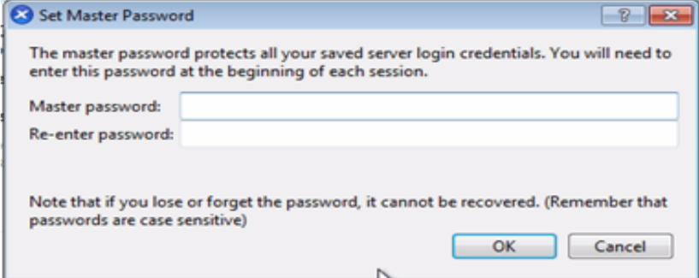

After you click OK, you’ll be brought back to the main screen, where you’ll see your XenServer already added to XenCenter.

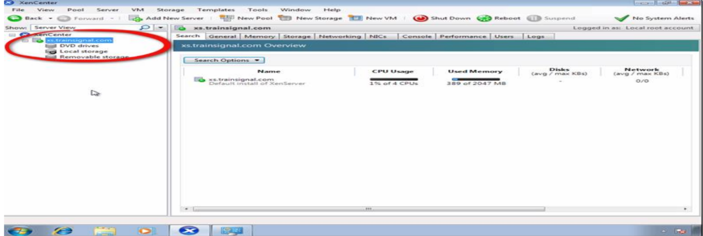

Step-:3 Create Storage Repository and Installing VM

Now Before Creating VM we have to Create Storage Repository first which is nothing but shared directory on XenCenter which holds all iso files and which is required to install Operating system on Xen Server its steps are as follows.Right click on Xenserver icon on xen center and click on New SR.

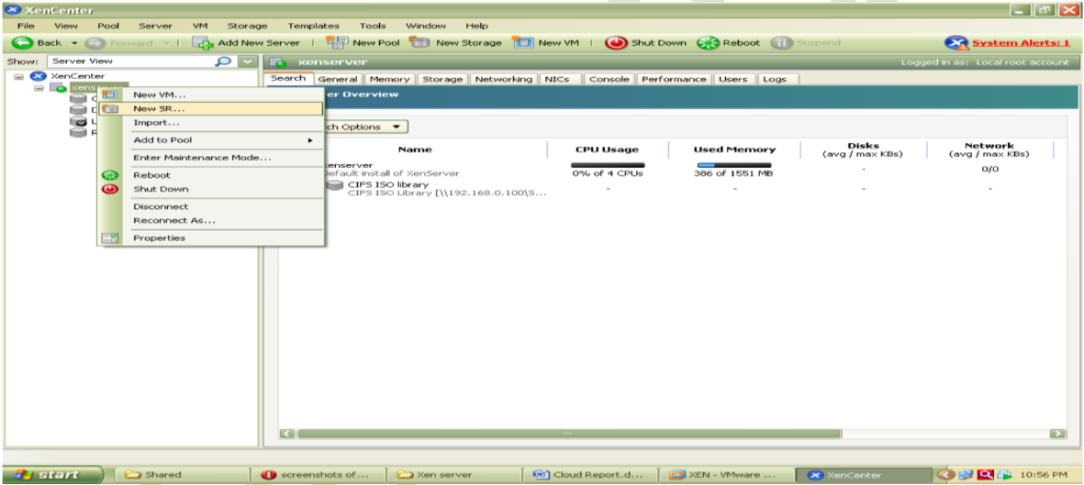

Now Select Windows CIFS library

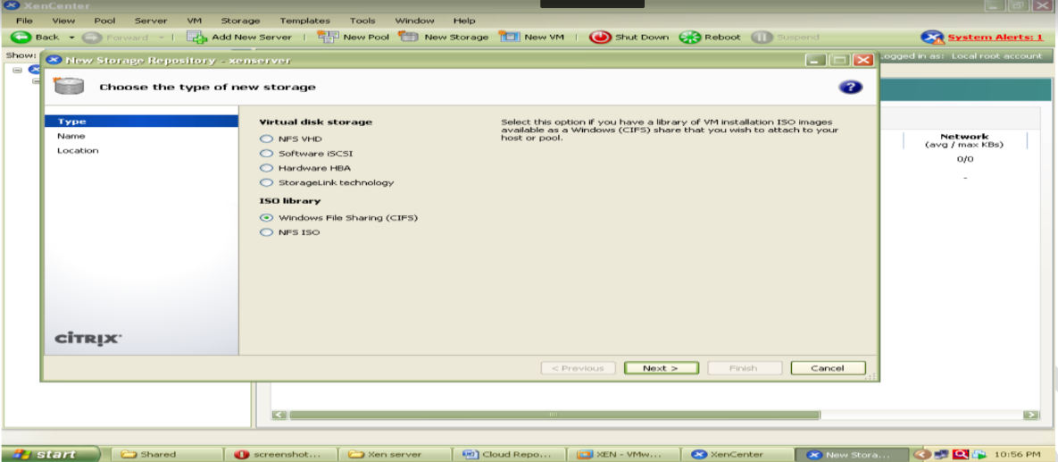

Specify Storage Repository Name

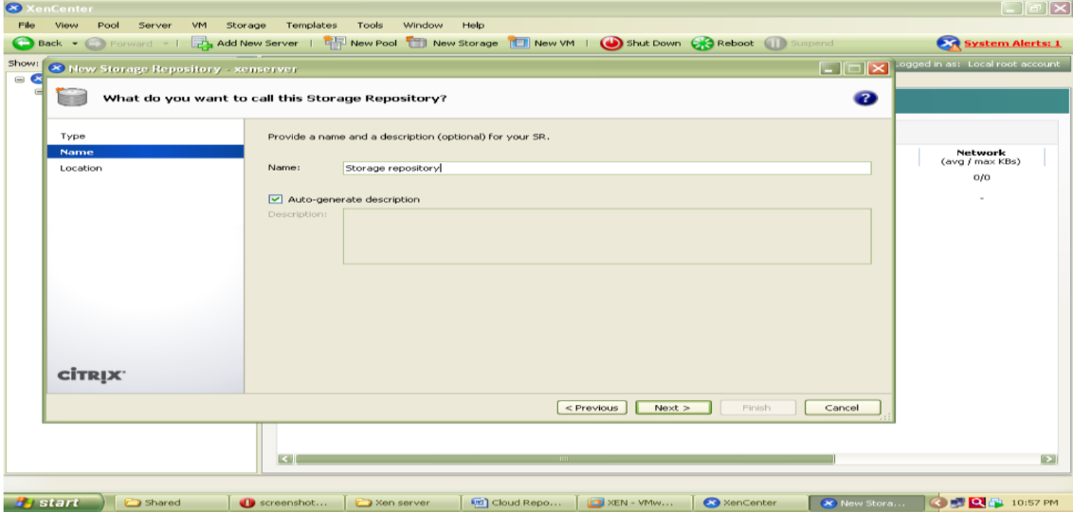

Now specify the path of the shared folder at client side which holds all iso files of os or VM which we are going to install on XenServer.

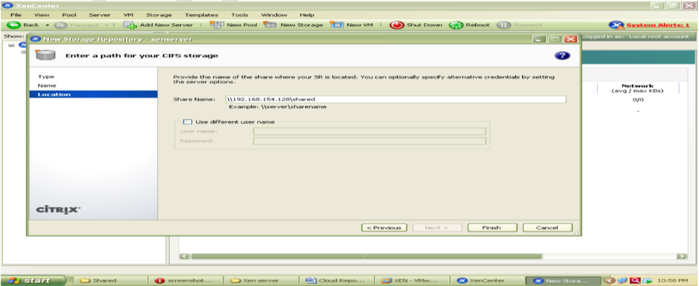

At the end Click on finish to create SR.

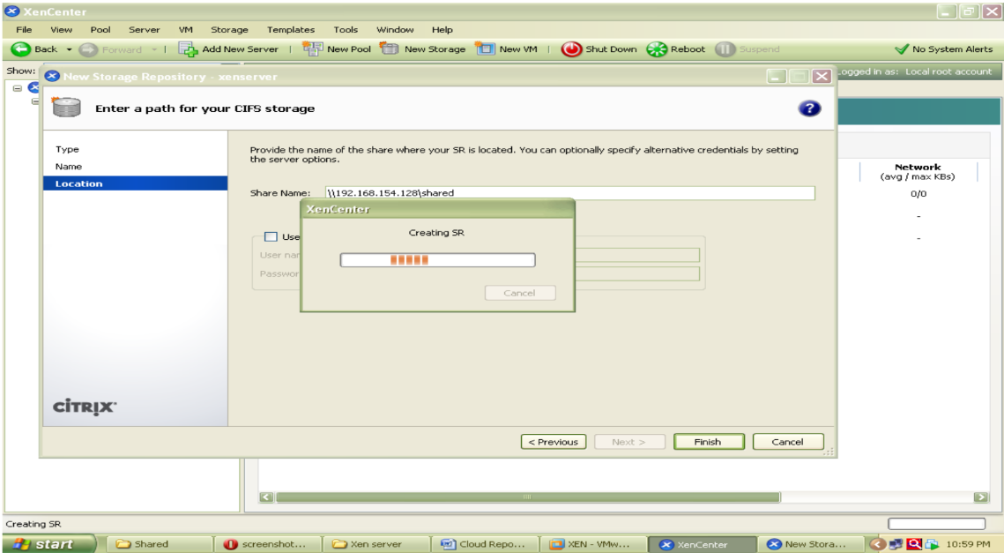

To check all iso files click on CIFS library and select storage this will show you all iso files.

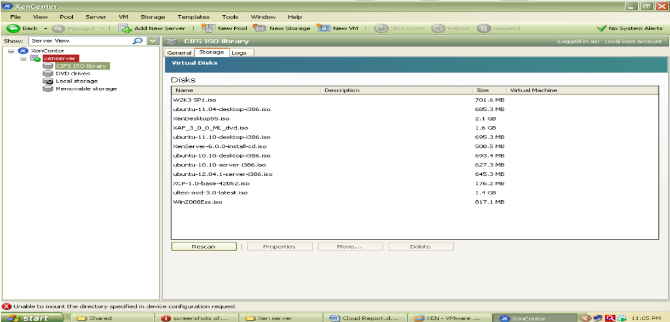

Installation of UBUNTU Server on Xenserver

Step 1 -: Right click on Xenserver icon on xen center and select New VM

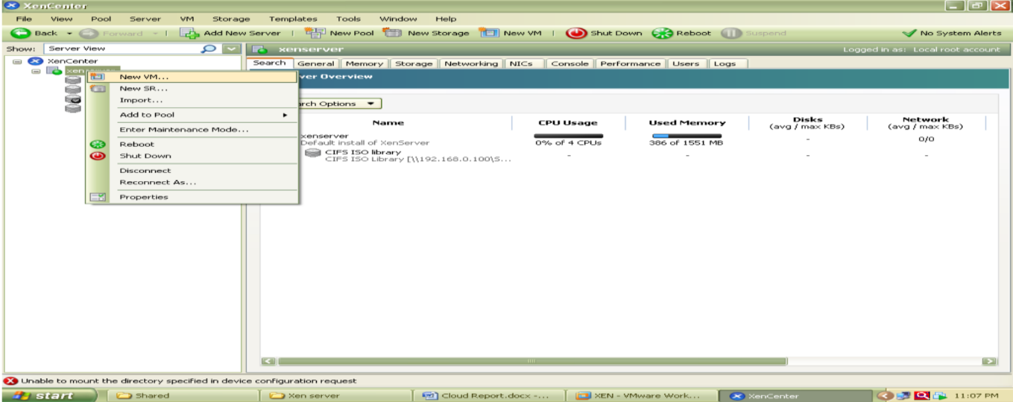

Now select an Operating System to be install here select Ubuntu Lucid Lynx and click on next

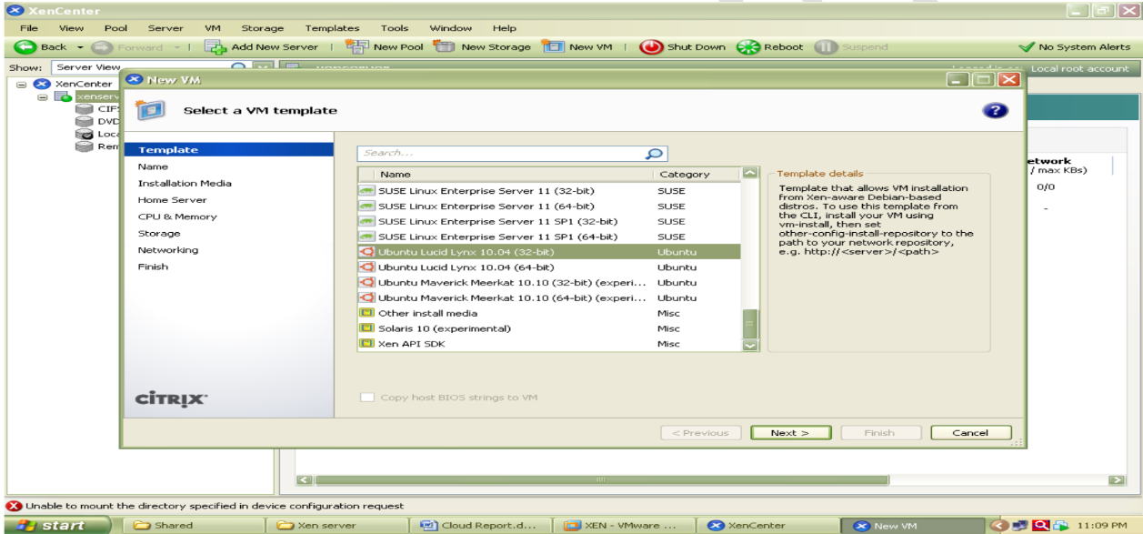

Now specify Instance Name as ubuntu server

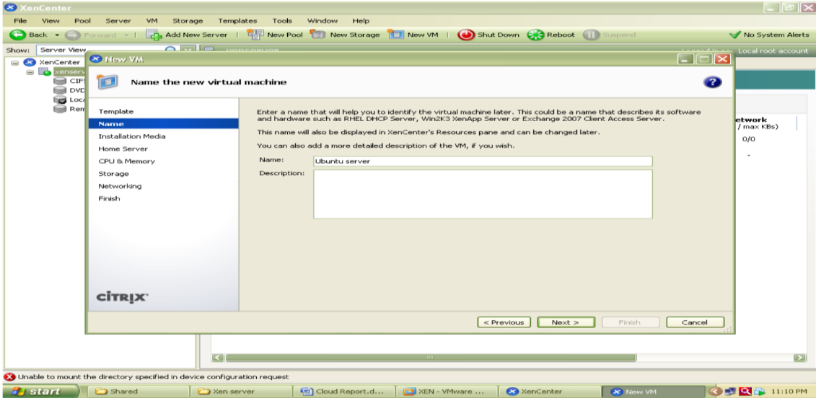

Select iso file of Ubuntu server 10.10 to be install

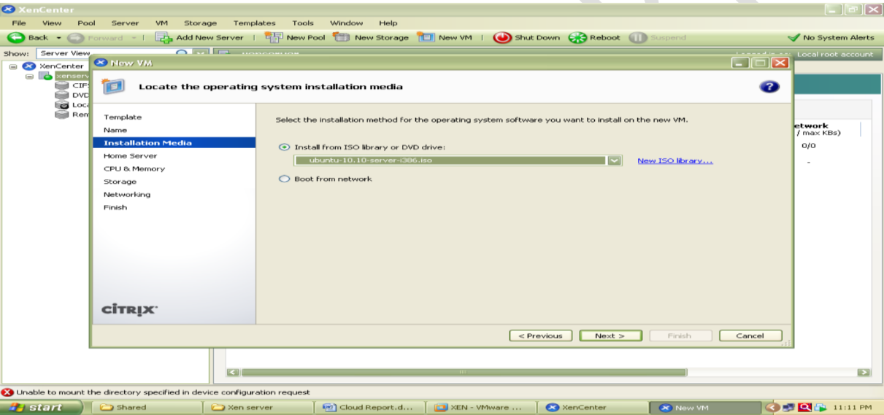

Now select hardware for vm i.e. no. of cpu’s and memory

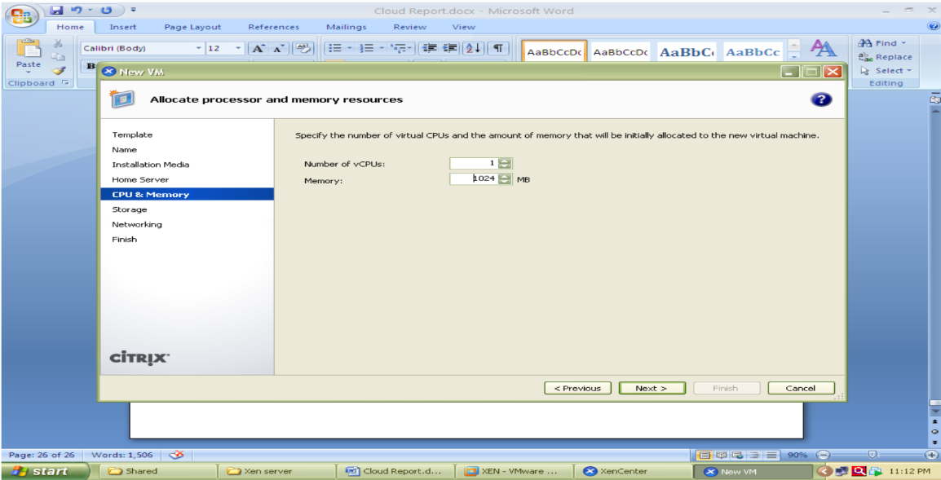

Select local storage

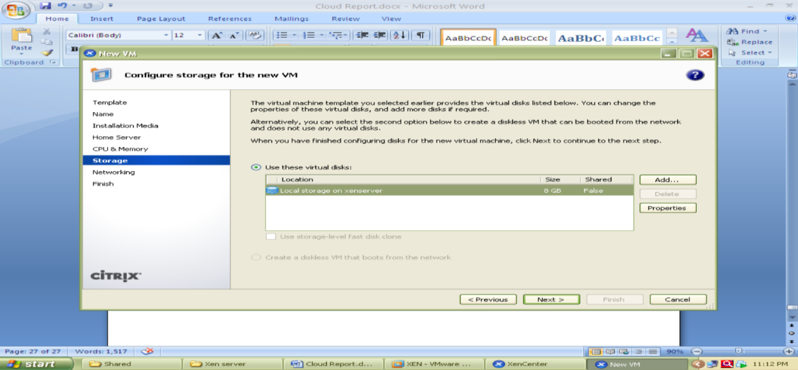

Select network

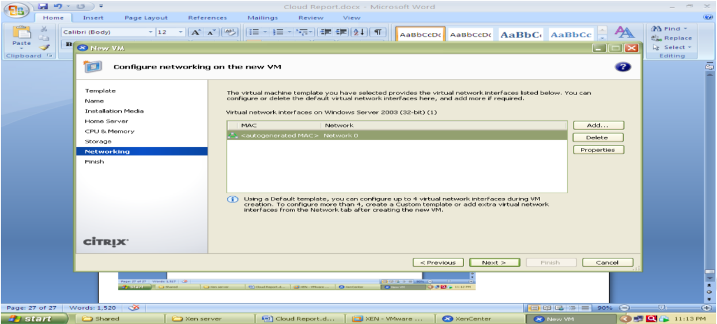

And click on finish

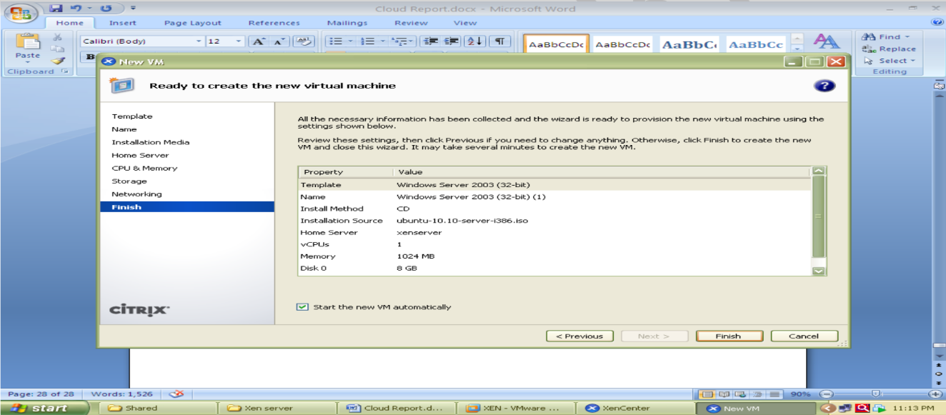Now go to the Console tab to install ubuntu and follow installation Steps.

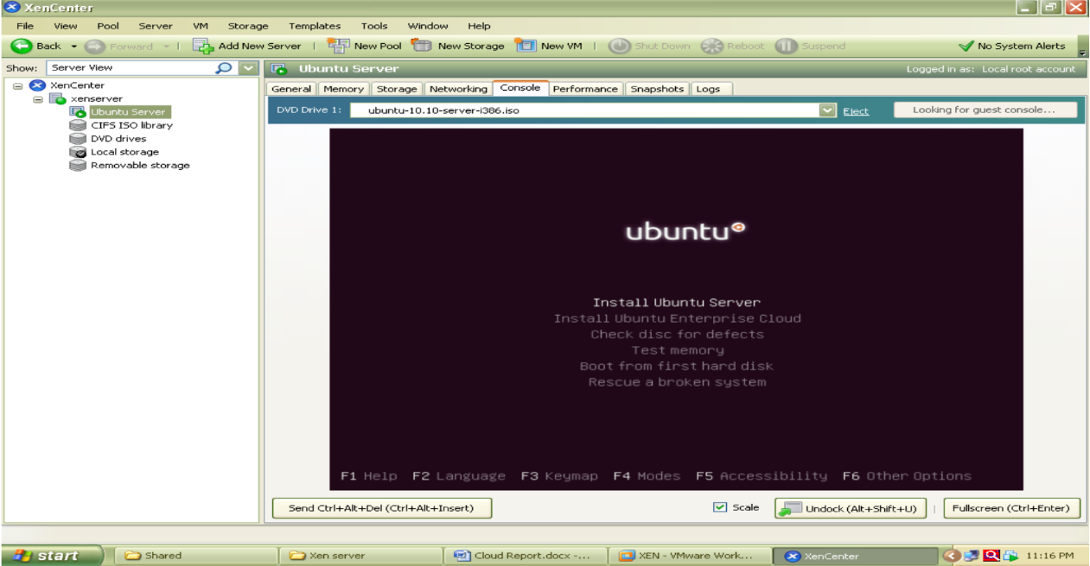

The Xen orchestra provides web based functionality of Xen Center.it provides access to all the VMs with their lifecycle management which are installed over Xen Server shown in figure

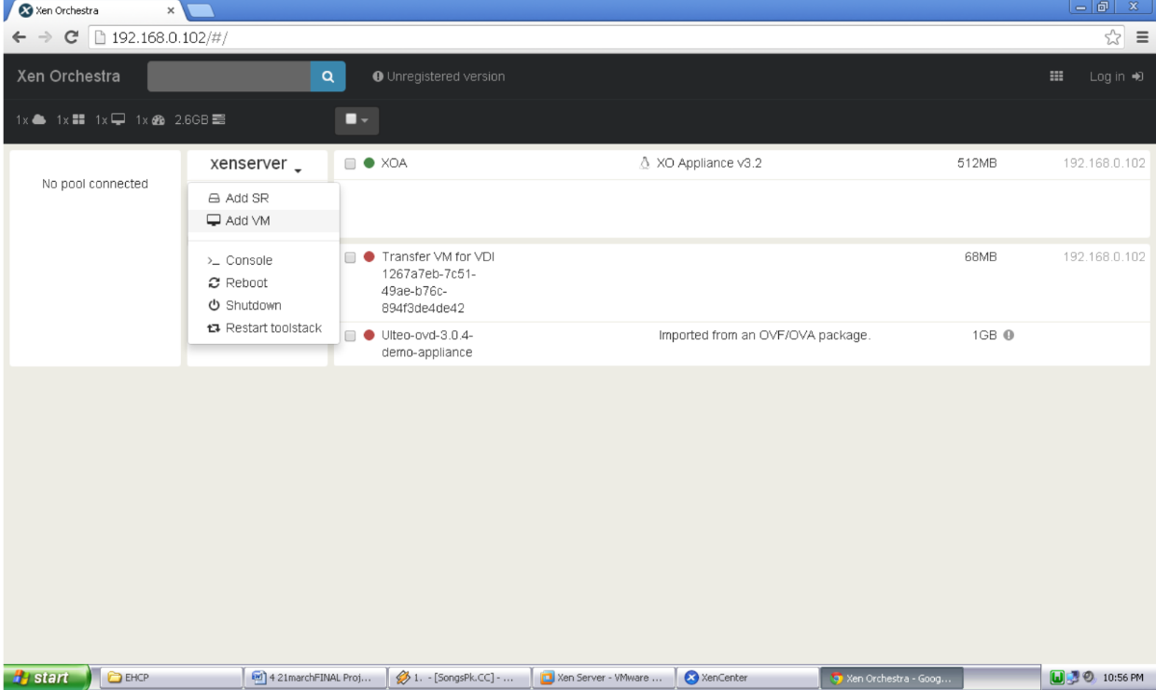

The Windows XP image running on Xen Orchestra over Google chrome web browser is shown in following screenshot

